DECODELABS INDUSTRIAL TRAINING KIT
PROJECT 1 SUBMISSION REPORT
Password Strength Checker
Submitted By : Mursalin Ahmed Sheikh
Batch : 2026
Track : Junior Analyst -- Defensive Logic
Date : June 20, 2026

1. PROJECT OVERVIEW
This report documents the completion of Project 1 of the DecodeLabs Industrial Training Kit (Batch 2026): the Password Strength Checker. The brief required a program capable of evaluating a user-supplied password and classifying it as Weak, Medium, or Strong based on length and character composition (uppercase letters, digits, and symbols), implemented through efficient string-handling and conditional logic rather than complex cryptography.
In addition to the baseline requirements, this submission implements several bonus security layers referenced in the training material (pattern recognition, dictionary/leetspeak checks, leaked-credential matching, entropy-based brute-force estimation, and a composite risk score), delivered through an interactive, hacker-themed graphical interface.
2. REQUIREMENT COMPLIANCE
The table below maps every requirement stated in the project brief to its implementation and current status.
# | Requirement | Implementation Summary | Status
1 | Password length validation (fail if < 8 characters) | Immediate WEAK verdict triggered when length is below 8 characters. | Met
2 | Detect uppercase letters | Flagged during a single linear character scan. | Met
3 | Detect numeric digits | Flagged during the same linear scan. | Met
4 | Detect special symbols | Checked against Python's string.punctuation set. | Met
5 | Display strength result (Weak / Medium / Strong) | Colour-coded verdict displayed at the end of the scan. | Met
6 | Linear-time validation (O(n) scan, per the IPO model) | All character-class flags computed in a single for-loop pass. | Met
7 | Efficient / Pythonic implementation style | Single-pass loop used instead of multiple any() calls, which would re-scan the string for each check; this preserves true O(n) behaviour. | Met (modified approach)
8 | Unicode / entropy awareness (bonus) | Unicode characters detected and incorporated into an entropy (bits) estimate. | Met
9 | Leaked / common password check (bonus) | Password compared against a built-in list of common breached passwords. | Met
10 | Character variety scoring (bonus) | Variety score (upper/lower/digit/symbol count) feeds the final classification. | Met
11 | RAM/memory exposure awareness (reference concept) | Documented as a known Python string-immutability limitation in code comments; not actively mitigated. | Acknowledged, not implemented
12 | Constant-time secret comparison (reference concept) | hmac.compare_digest() utility included in the codebase for future use. | Met (utility provided)
13 | Validation-before-encryption principle | Applies to Project 2 (Hashing & Encryption); outside the scope of Project 1. | Not Applicable

3. ADDITIONAL SECURITY LAYERS IMPLEMENTED (BEYOND BRIEF)
The following capabilities were added voluntarily, beyond the minimum brief, to demonstrate a broader security mindset:
- Sequential-character detection (e.g. “abc”, “123”)
- Repeated-character detection (e.g. “aaa”, “111”)
- Keyboard-walk pattern detection (e.g. “qwerty”, “asdfgh”)
- Leetspeak decoding prior to dictionary / leak-list comparison
- Entropy-based brute-force crack-time estimate (online vs. offline attack speeds)
- Composite 0–100 security risk score combining all layers
- Interactive, hacker-themed animated GUI (live border-glow feedback, layer-by-layer scan animation, progress bar, animated strength meter)

4. TEST CASE VALIDATION & SCREENSHOT EVIDENCE
Three representative passwords were tested to confirm correct behaviour across all three strength tiers.
Test Case | Password Used | Length | Entropy | Leaked / Pattern Match | Score | Verdict
Weak | password | 8 | 37.6 bits | Yes | 0 / 100 | WEAK
Medium | passkey@123 | 11 | 67.0 bits | No (sequential run flagged) | 56 / 100 | MEDIUM
Strong | 57r0nGP@55w07dd3c0de51@8 | 24 | 157.3 bits | No | 94 / 100 | STRONG

Note on brute-force estimates: at 67.0 bits and 157.3 bits of entropy, the calculated offline crack times (~4.7 centuries and ~7.13 × 10²⁷ centuries respectively) already exceed practical attack windows, illustrating why both the Medium and Strong samples resist brute force at very different orders of magnitude.

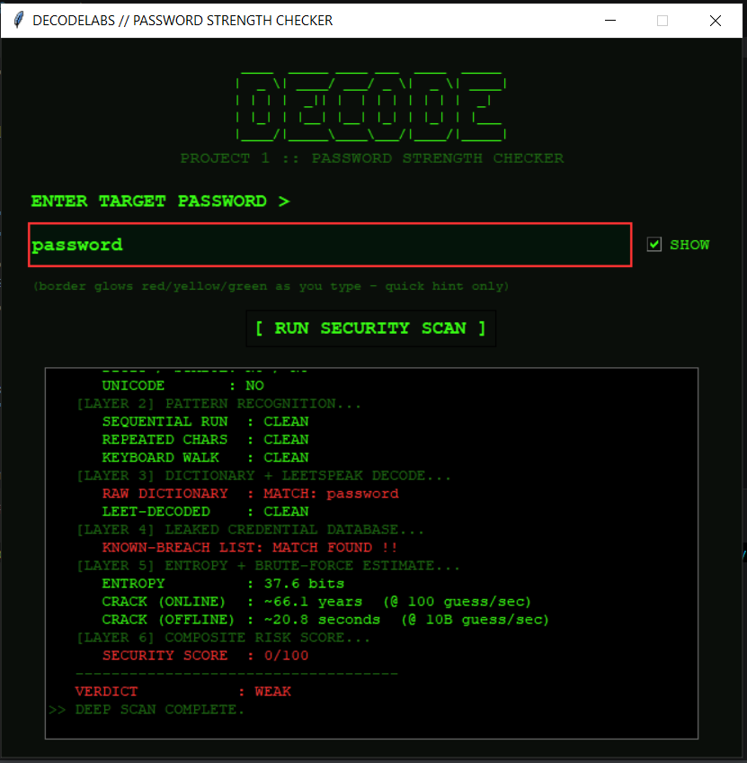
Figure 1: Weak Password Test Output
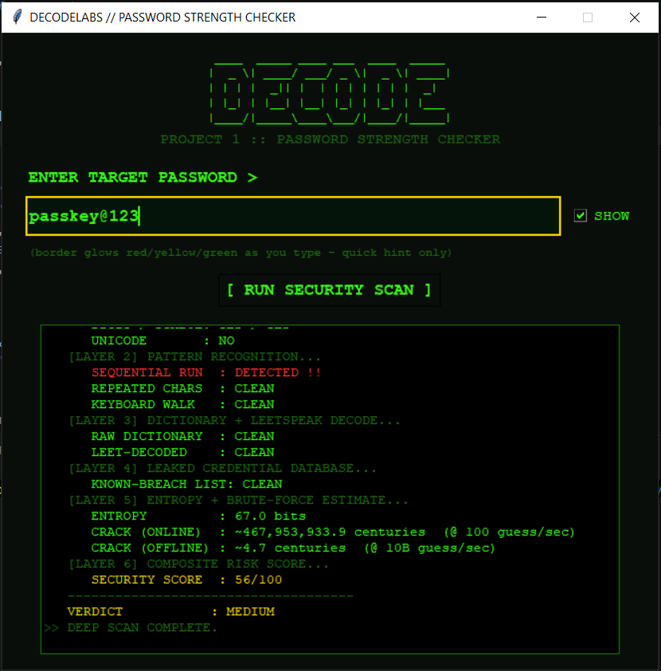
Figure 2: Medium Password Test Output
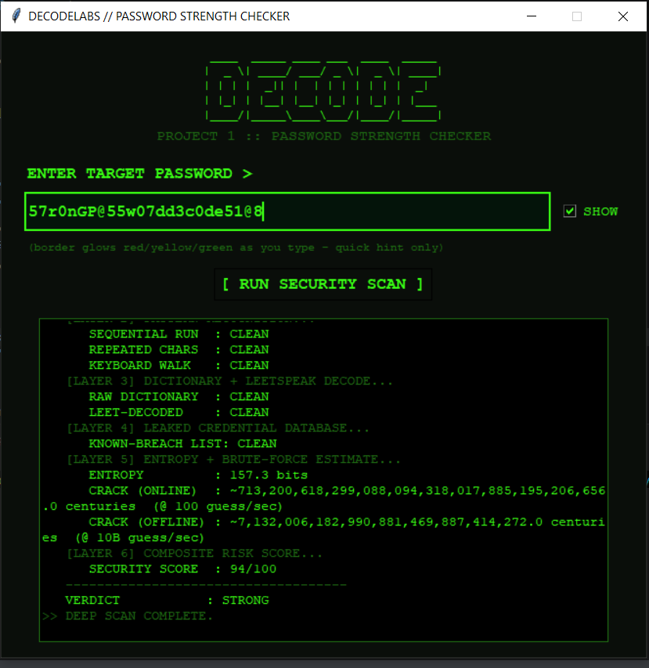
Figure 3: Strong Password Test Output

5. EVALUATION RUBRIC
The brief's qualification criteria (completion, quality, and standards) are expanded below into a detailed self-assessment rubric.
Criteria | Type | Evidence | Status
Functional Correctness | Core | All three test cases (Weak / Medium / Strong) produced logically consistent, correct verdicts. | Met
Computational Efficiency | Core | Single linear-pass (O(n)) character scan, per the brief's IPO model. | Met
Security Reasoning Depth | Bonus | Six-layer analysis: charset, pattern recognition, dictionary/leetspeak, leak database, entropy, composite score. | Exceeded
Code Readability & Structure | Core | Modular functions with inline comments cross-referencing the brief. | Met
User Interface / Usability | Bonus | Animated hacker-themed GUI with live feedback, progress bar, and strength meter. | Exceeded
Documentation & Test Evidence | Core | Three test cases documented; screenshots pending insertion in Section 4. | Met (pending images)

6. CONCLUSION
Based on the compliance table in Section 2 and the validated test cases in Section 4, Project 1 satisfies every mandatory requirement defined in the DecodeLabs brief: length validation, character-class detection, strength classification, and linear-time logic.

